**Step 1:**

Login to <https://helpline.wipro.com> using your Wipro ADID.

**Step 2:**

Click on IMG (follow below screenshot)

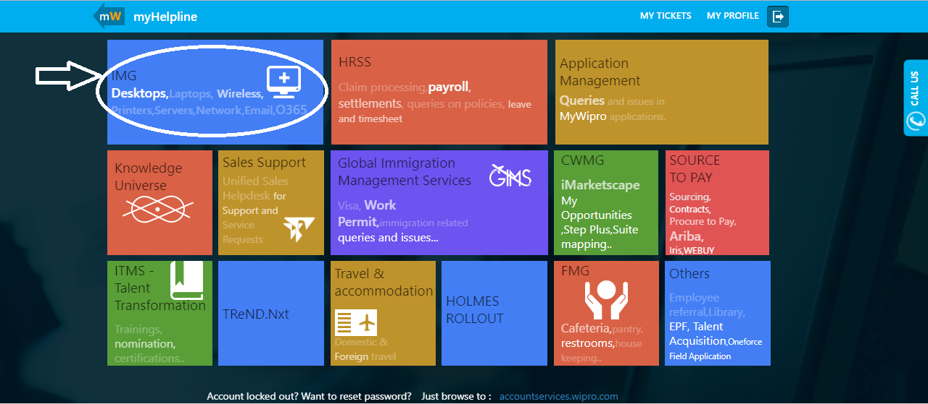

**Step 3:**

Type **TopGear VDI** in the textbox (follow below screenshot)

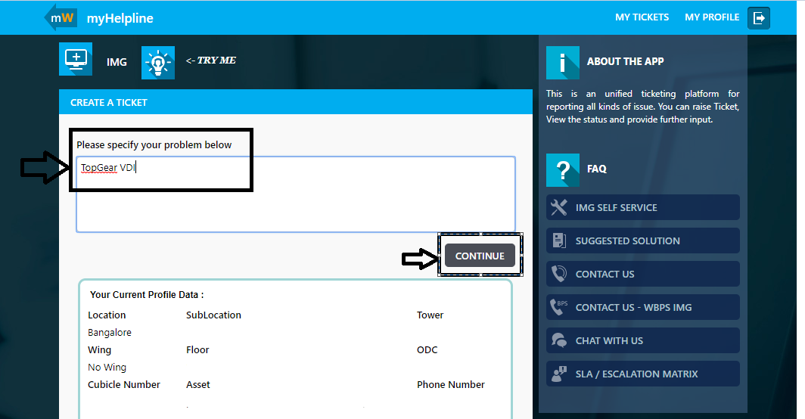

**Step 4:**

Select **TopGear-VDI-Virtual Infrastructure** under related classification (follow below screenshot)

* Once you select the classification, specify your complete issue in below format,
  + User ADID
  + VDI pool / Training name
  + Complete description of the issue
  + Attach screenshot of the error that you may encounter
* Now click on **SUBMIT** button.

